Media Information

The National Allotment Society

O’Dell House, Hunters Road, Northants, NN17 5JE
Telephone: 01536 266576
Email: Marketing@thenas.org.uk
www.thenas.org.uk

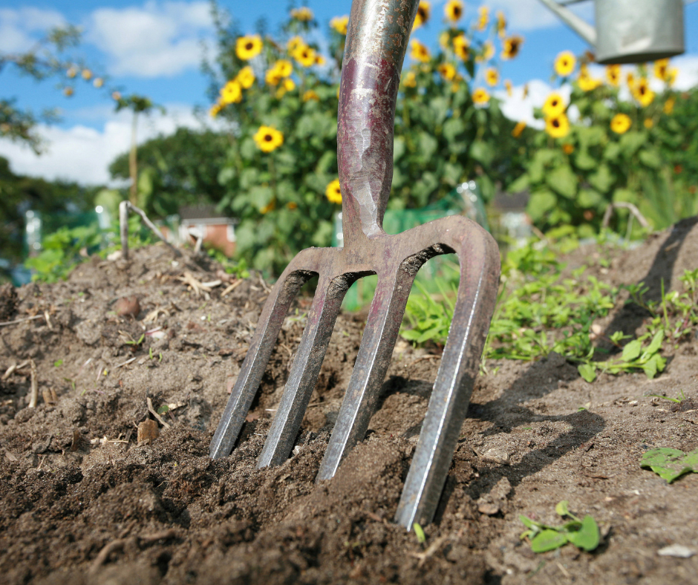

About The National Allotment Society
Founded in the early 20th century, The National Allotment Society (NAS) is the leading representative body for UK allotment holders, upholding the interests and rights of the allotment community, with over 130,000 members.
We work with government at national and local levels, landlords, developers and charities to provide, promote and preserve allotments – highlighting the social and environmental benefits of growing sites and preserving allotments for future generations.
Membership comes with a host of benefits including free initial legal advice, allotment liability insurance, horticultural discounts, allotment expertise, advice and guidance.
We operate as a not-for-profit cooperative, with 11 regional committees providing regional support and guidance for allotment sites, associations and individuals.
Our head office legal team work with the Secretary of State, advising in cases of allotment land disposal, we also offer legal advice and training to associations and councils – supporting them to manage sites and tenancies.
In 2011, we received the esteemed patronage of His Royal Highness King Charles III and were delighted when he announced his continued patronage in 2024. His deep passion for gardening, commitment to environmental causes, and steadfast dedication to preserving the UK's rich traditions make him an invaluable advocate for our mission.

The origins of allotments
- In 1887, the Allotments Act was introduced, which allowed local authorities to provide plots of land for allotments, although it was not very successful.
- Twenty years later in 1907, Parliament passed the Smallholding and Allotments Act, which forced councils to facilitate allotments where there was demand. This act still stands today, with some amendments, and it dictates that local authorities should provide plots if there is demand from more than 6 people.
- The majority of allotments were developed under the Defence of the Realm Act of 1916 which allowed local authorities to commandeer as much land as possible for conversion to wartime allotments - this was the start of a lot of allotments.
- By February 1918 there was a cry for more allotments in urban areas. As a result, the Board of Agriculture pressed to have the compulsory powers of local authorities extended to enable the grounds of unoccupied private gardens to be used for growing food. After the war land was still being claimed for allotment use.
- In December 1918, 26 local authorities provided 5,000 new allotments.

- Post WWll there were 1.4 million allotments. After the war, allotments became less and less prominent with the disappearance of rationing and the arrival of cheap mass-produced food. With this decline, local authorities started selling off land.

- By the 1970s, the number of allotments had been cut by two thirds, and while there was still some interest in growing your own veg, by 1997 there were 265,000 plots, 16% of which were vacant.

- NAS now estimate that there are currently about 330,000 allotments in the UK.

Allotment statistics
A study completed by APSE in August 2025 reported on local authority allotment statistics.
- At least 174,000 people were on local authority waiting lists across Britain in 2023 according to Freedom of Information data obtained from councils — suggesting demand continues to outstrip supply.
- 63 % of local authorities report average waiting times of more than 18 months for an allotment plot, showing how persistent and widespread high demand remains.
- The demand for allotments is still high, with 30% of local authorities having over 1000 people on the waiting list for an allotment and 57% with over 300. 88% said their waiting list was regularly updated.

- 35 % of local authorities indicated plans to offer a greater number of allotment plots in response to demand pressures — a shift from previous years’ figures
- It is clear that demand is still high for allotment plots, the waiting lists often being in large urban areas.
Find the local authority APSE survey here

Managing and creating allotments
- The National Allotment Society work to help reduce waiting lists by working with councils, allotment associations and sites to identify and manage behavioural and non-cultivation issues.
- We recommend the strategy of splitting plots to provide new allotmenteers with a manageable plot size and to free up additional plots.
- We provide training to Councils and forums to Parish Councils, to educate and guide on managing allotments.

Creating new allotments

The National Allotment Society have taken a proactive approach to engaging with new housing developments – to encourage allotments to be incorporated into residential building plans.

We work with Developers, Planning Officers and Building experts to provide guidance and allotment expertise, encouraging the integration of plots into building plans. NAS also provides ongoing information and guidance on self-management and advises on securing long term use and protection for the new allotment site.

In 2023, an examination of planning applications shows that there are now over 100 planning applications for new housing developments which include new allotment sites.

Across the UK, new housing developments are increasingly including allotments. Recent examples include 26 new plots in Oxfordshire, planned growing space at Gilden Park in Harlow, and expanded allotments in Borehamwood. In West Sussex, new homes were approved only after proposals to re-provide and increase allotment space were included, highlighting the importance of growing spaces in modern communities.

The Benefits of Allotments

Allotments are valuable community assets, boosting health & wellbeing, providing sustainable growing spaces and creating biodiverse green corridors. Not only are they a valuable part of our UK heritage, but they play an important part in our future too.
Rich Green Spaces
Historically seen as simply spaces for individuals to enjoy, studies increasingly show the green value of allotment sites. Allotments are rich in biodiversity, creating green spaces for wildlife and pollinators throughout the country.
The quality of soil on allotments creates a unique environment from which all life can emerge – particularly precious in urban areas. Even in rural areas, the ecological value of sites per square metre, surpasses that of adjoining industrial farmed agricultural land.
Natural England acknowledges allotments as a firm part of 'Green Infrastructure' – a network of connected green features in the landscape that play an important role in urban and rural environments. They improve health and wellbeing, air quality, biodiversity, nature recovery and resilience to and mitigation of climate change. For more information see Natural England's website and learn about the importance of Green Infrastructure. Natural England >
Social and Community
Allotments serve the wider community, hosting educational projects, mental health programmes, food sharing schemes, sensory gardens, and green social prescribing initiatives. According to the NAS 2025 survey, over 60% of allotment sites host at least one community or educational project, and more than 50% provide spaces for outreach, social prescribing, or school programmes. Gardening also combats loneliness, builds social connections, and allows people to actively participate in managing their local site.
According to the National Allotment Society’s 2025 national survey, over 80 % of plot holders said their allotment helped them build social connections, with many describing their site as a ‘community in itself’ as they share skills, seeds, surplus crops and support one another
Allotments have a huge educational value too - offering the chance for those without large gardens to learn how to grow their own and gain knowledge from the experienced allotment community. Allotments offer a rich natural learning environment away from classrooms. Many sites run primary and secondary educational projects in conjunction with local schools and clubs, teaching young people about nature and the value of growing.
"Allotments are more than plots of land—they are communities in miniature. They bring people together, share skills, and create networks of support that help people thrive, especially in challenging times."
— National Allotment Society
Health and Wellbeing
There is a growing awareness of the role that gardening plays in improving mental health. Many allotment gardeners will tell you that a spell on the plot nurturing plants and contemplating nature makes them feel calmer and more hopeful and there have been recent studies that have measured this benefit.
In 2018 the UK Government produced a 25 Year Environment Plan, which acknowledges that connecting people to their environment will also improve their health and well-being.
The social contact offered by gardening in an allotment environment helps to combat the lack of social capital embodied by loneliness, which has the equivalent risk to health as consuming 15 cigarettes daily and is twice as harmful as obesity. A study in the Netherlands showed that every 10 per cent increase in exposure to green space translated into an improvement in health equivalent to being five years younger, with similar benefits found by studies in Canada and Japan.
The physical benefits of regular spells of gardening help plot-holders to keep fit even if they have sedentary jobs. The twisting and turning involved in gardening helps to maintain good gait and balance in older gardeners and also helps with cognitive decline.
Getting outside is also good for us. Depending on your skin type, spending just 15-90 minutes a day out in the summer sunshine can build up your levels of immune boosting vitamin D.
Gardening on allotments improves mental health, reduces stress, and provides gentle physical activity. Exposure to green space has measurable health benefits, with studies linking it to lower risks of obesity, reduced stress, and even biological markers equivalent to being several years younger. The NAS survey found that nearly 90% of plot holders reported improved wellbeing from regular allotment gardening, while over 70% said it helped them stay physically active.
The Personal Value of Growing Your Own
If managed properly, an allotment can produce enough food to supplement a family's weekly shop, with fresh fruit and vegetables over the year. Allotment gardeners can choose to garden organically and avoid ingesting chemicals that are likely to be present on shop bought fruit and vegetables.
In a survey of National Allotment Society members nearly every person said their love of allotment gardening comes from the fresh air, home grown produce, healthy lifestyle and like-minded people this activity offers. NAS survey respondents highlighted that the main benefits of allotment gardening are access to homegrown produce (95%), outdoor activity (92%), and the social community (88%). Many new gardeners gain valuable skills, and the satisfaction of eating their first homegrown vegetables is a lasting reward.
As many new plot-holders discover, growing vegetables requires acquiring new knowledge and skills and the satisfaction gained from eating their first home grown tomato or new potato makes them taste even more delicious!

Cost of living & allotments
- The average cost of running a 300 square yard / 250 square metre plot was £247 per annum. An approximate value of the produce could be as much as £1,909.82 per plot, plus the inestimable personal satisfaction of growing your own and getting valuable exercise into the bargain.

- Average allotment gardener on a 300 square yard plot came out at 203 hours per year or costed at the minimum wage rate average £1982.50.

- A study was commissioned and funded by the Brighton and Hove Allotment Federation to examine and quantify the benefits of allotments to residents and to the Council.

- This suggested that allotments make significant financial impact to the wider community and thus the cost of living.

- A conservative financial valuation of just a selection of these wider impacts shows that each plot benefits the city by at least £166.84 p/a (excluding the value of food produced).

- Overall, the potential benefits to a city - including wider council departments - are could be as much as £385,567 each year, alongside food worth an estimated £1.12m.

- "For many families, an allotment isn’t a hobby—it’s a lifeline. Growing your own food reduces grocery bills, strengthens food security, and gives people control over what they eat."
— National Allotment Society

- Find more about the study here

NAS Membership Details
The National Allotment Society (NAS) represents over 130,000 members across the UK, including individual plot holders, allotment associations, landowners and local authorities. Membership is open to anyone with an interest in allotments- even if they don’t have one, from councils and housing associations managing sites to individuals growing their own fruit and vegetables.

Member Benefits:
  - Legal Advice & Support: Free initial guidance on tenancy disputes, land issues, and allotment law.
  - Insurance: Allotment liability insurance to protect plot holders and associations.
  - Horticultural Expertise: Access to growing advice, guidance on organic methods, pest management, and best practice for managing plots.
  - Discounts: Members enjoy horticultural discounts on seeds, and more.
  - Training & Resources: Workshops and online guidance for site management, governance, and community engagement.
  - Regional Support:
NAS operates 11 regional committees that provide tailored support and guidance to local sites, associations, and members. These committees offer training, advice, and networking opportunities, helping new and experienced plot holders maximise their allotment experience.

Member Impact:
Membership is not just about individual benefits. Members actively contribute to the wider allotment community by sharing skills, mentoring new gardeners, running community projects, and supporting educational and social initiatives.

